**Гимнастика с элементами логоритмики.**

[](http://ok.ru/dk?cmd=PopLayerPhoto&st.layer.cmd=PopLayerPhotoOuter&st.layer.type=GROUP&st.layer.revNav=off&st.layer.limitedUi=false&st.layer.sphotoIds=803764285189;803764284933;803764284677;803764284421;803764284165;803764283909;803764283653;803764283397;803764283141;803764282885&st.layer.fre=on&st.layer.showNav=on&st.layer.photoAlbumId=53823353978885&st.layer.epm=off&st.layer.photoId=803764285189&st.layer.opl=off&st.layer.navStartPhotoId=803764285189&st.layer.sbd=off&st.cmd=userMain&st._aid=GroupTopicLayer_openPhotoLayer)

[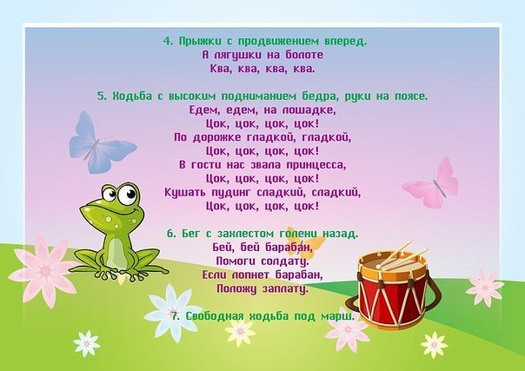](http://ok.ru/dk?cmd=PopLayerPhoto&st.layer.cmd=PopLayerPhotoOuter&st.layer.type=GROUP&st.layer.revNav=off&st.layer.limitedUi=false&st.layer.sphotoIds=803764285189;803764284933;803764284677;803764284421;803764284165;803764283909;803764283653;803764283397;803764283141;803764282885&st.layer.fre=on&st.layer.showNav=on&st.layer.photoAlbumId=53823353978885&st.layer.epm=off&st.layer.photoId=803764284933&st.layer.opl=off&st.layer.navStartPhotoId=803764284933&st.layer.sbd=off&st.cmd=userMain&st._aid=GroupTopicLayer_openPhotoLayer)

[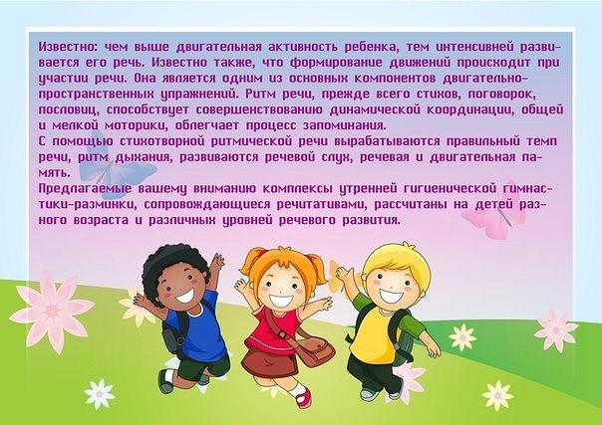](http://ok.ru/dk?cmd=PopLayerPhoto&st.layer.cmd=PopLayerPhotoOuter&st.layer.type=GROUP&st.layer.revNav=off&st.layer.limitedUi=false&st.layer.sphotoIds=803764285189;803764284933;803764284677;803764284421;803764284165;803764283909;803764283653;803764283397;803764283141;803764282885&st.layer.fre=on&st.layer.showNav=on&st.layer.photoAlbumId=53823353978885&st.layer.epm=off&st.layer.photoId=803764284677&st.layer.opl=off&st.layer.navStartPhotoId=803764284677&st.layer.sbd=off&st.cmd=userMain&st._aid=GroupTopicLayer_openPhotoLayer)

[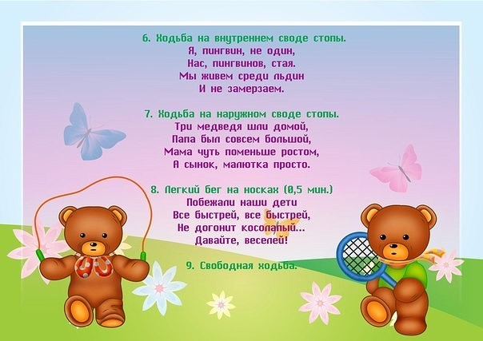](http://ok.ru/dk?cmd=PopLayerPhoto&st.layer.cmd=PopLayerPhotoOuter&st.layer.type=GROUP&st.layer.revNav=off&st.layer.limitedUi=false&st.layer.sphotoIds=803764285189;803764284933;803764284677;803764284421;803764284165;803764283909;803764283653;803764283397;803764283141;803764282885&st.layer.fre=on&st.layer.showNav=on&st.layer.photoAlbumId=53823353978885&st.layer.epm=off&st.layer.photoId=803764284421&st.layer.opl=off&st.layer.navStartPhotoId=803764284421&st.layer.sbd=off&st.cmd=userMain&st._aid=GroupTopicLayer_openPhotoLayer)

[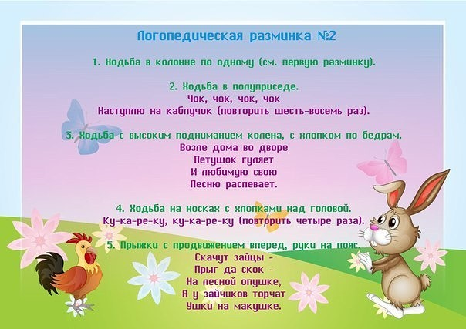](http://ok.ru/dk?cmd=PopLayerPhoto&st.layer.cmd=PopLayerPhotoOuter&st.layer.type=GROUP&st.layer.revNav=off&st.layer.limitedUi=false&st.layer.sphotoIds=803764285189;803764284933;803764284677;803764284421;803764284165;803764283909;803764283653;803764283397;803764283141;803764282885&st.layer.fre=on&st.layer.showNav=on&st.layer.photoAlbumId=53823353978885&st.layer.epm=off&st.layer.photoId=803764284165&st.layer.opl=off&st.layer.navStartPhotoId=803764284165&st.layer.sbd=off&st.cmd=userMain&st._aid=GroupTopicLayer_openPhotoLayer)

[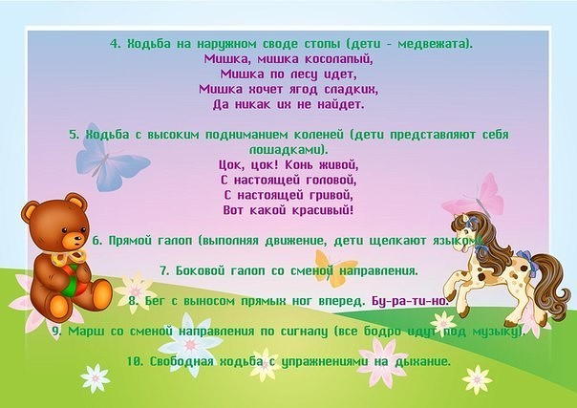](http://ok.ru/dk?cmd=PopLayerPhoto&st.layer.cmd=PopLayerPhotoOuter&st.layer.type=GROUP&st.layer.revNav=off&st.layer.limitedUi=false&st.layer.sphotoIds=803764285189;803764284933;803764284677;803764284421;803764284165;803764283909;803764283653;803764283397;803764283141;803764282885&st.layer.fre=on&st.layer.showNav=on&st.layer.photoAlbumId=53823353978885&st.layer.epm=off&st.layer.photoId=803764283909&st.layer.opl=off&st.layer.navStartPhotoId=803764283909&st.layer.sbd=off&st.cmd=userMain&st._aid=GroupTopicLayer_openPhotoLayer)

[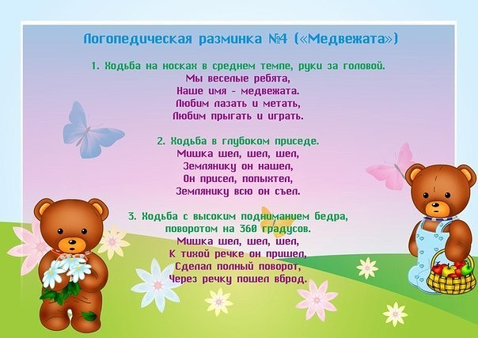](http://ok.ru/dk?cmd=PopLayerPhoto&st.layer.cmd=PopLayerPhotoOuter&st.layer.type=GROUP&st.layer.revNav=off&st.layer.limitedUi=false&st.layer.sphotoIds=803764285189;803764284933;803764284677;803764284421;803764284165;803764283909;803764283653;803764283397;803764283141;803764282885&st.layer.fre=on&st.layer.showNav=on&st.layer.photoAlbumId=53823353978885&st.layer.epm=off&st.layer.photoId=803764283653&st.layer.opl=off&st.layer.navStartPhotoId=803764283653&st.layer.sbd=off&st.cmd=userMain&st._aid=GroupTopicLayer_openPhotoLayer)

[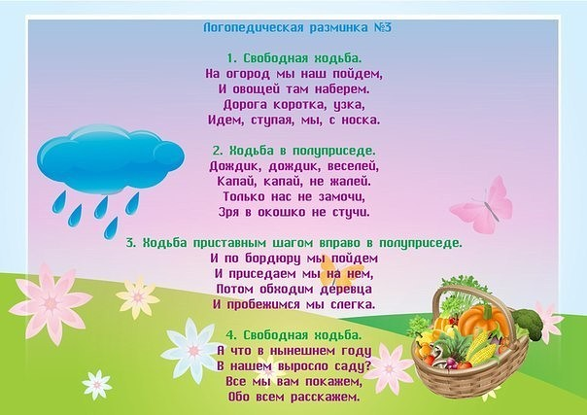](http://ok.ru/dk?cmd=PopLayerPhoto&st.layer.cmd=PopLayerPhotoOuter&st.layer.type=GROUP&st.layer.revNav=off&st.layer.limitedUi=false&st.layer.sphotoIds=803764285189;803764284933;803764284677;803764284421;803764284165;803764283909;803764283653;803764283397;803764283141;803764282885&st.layer.fre=on&st.layer.showNav=on&st.layer.photoAlbumId=53823353978885&st.layer.epm=off&st.layer.photoId=803764283397&st.layer.opl=off&st.layer.navStartPhotoId=803764283397&st.layer.sbd=off&st.cmd=userMain&st._aid=GroupTopicLayer_openPhotoLayer)

[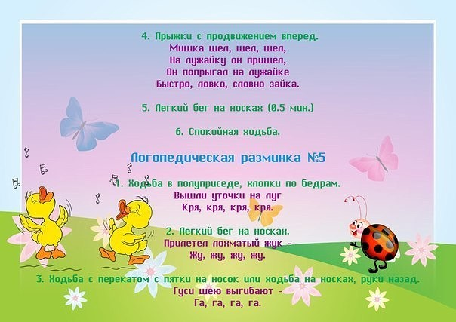](http://ok.ru/dk?cmd=PopLayerPhoto&st.layer.cmd=PopLayerPhotoOuter&st.layer.type=GROUP&st.layer.revNav=off&st.layer.limitedUi=false&st.layer.sphotoIds=803764285189;803764284933;803764284677;803764284421;803764284165;803764283909;803764283653;803764283397;803764283141;803764282885&st.layer.fre=on&st.layer.showNav=on&st.layer.photoAlbumId=53823353978885&st.layer.epm=off&st.layer.photoId=803764283141&st.layer.opl=off&st.layer.navStartPhotoId=803764283141&st.layer.sbd=off&st.cmd=userMain&st._aid=GroupTopicLayer_openPhotoLayer)

[](http://ok.ru/dk?cmd=PopLayerPhoto&st.layer.cmd=PopLayerPhotoOuter&st.layer.type=GROUP&st.layer.revNav=off&st.layer.limitedUi=false&st.layer.sphotoIds=803764285189;803764284933;803764284677;803764284421;803764284165;803764283909;803764283653;803764283397;803764283141;803764282885&st.layer.fre=on&st.layer.showNav=on&st.layer.photoAlbumId=53823353978885&st.layer.epm=off&st.layer.photoId=803764282885&st.layer.opl=off&st.layer.navStartPhotoId=803764282885&st.layer.sbd=off&st.cmd=userMain&st._aid=GroupTopicLayer_openPhotoLayer)